LAB NO. 03

CONSTRUCTOS AND DESTRUCTORS IN C++

Following are the lab objectives:
Lab
Objectives
- Learn to define constructors and destructors in classes
- Learn to define constrctors and destructors types in classes

Student
ID 10011 Student Name Sajjal Tariq

Marks Obtained
Marks

Comments

Task 1 15
Task 2 15
Task 3 15
Total 45
Marks
Lab Instructor

Lab Objectives and CLOs Mapping

Lab Objectives | CLOs
Lab Objectives | a | b | c
1
2
3

Instructions
- This is individual Lab work/task.
- Complete this lab work within lab timing.
- Discussion with peers is not allowed.
- You can consult any book, notes & Internet.
- Copy paste from Internet will give you negative marks.
- Lab work is divided into small tasks, complete all tasks sequentially.
- Show solution of each lab task to your Lab Instructor.
- In-Lab Exercises/Tasks
- Write your code at provided space after each question
- You need to upload code for all tasks at Google Class.

Constructor and Destructor in C++
Constructor and Destructor are the special member functions of the class which are created by the C++ compiler or can be defined by the user.
Constructor is used to initialize the object of the class while destructor is called by the compiler when the object is destroyed.

What is Constructor in C++?
A constructor is a special member function of a class and shares the same name as of class, which means the constructor and class have the same name. Constructor is called by the compiler whenever the object of the class is created, it allocates the memory to the object and initializes class data members by default values or values passed by the user while creating an object. Constructors don’t have any return type because their work is to just create and initialize an object.

What is the basic syntax of Constructor in C++?
The basic syntax of the constructor is given below:
class class_name{
private:
// private members

public:

// declaring constructor

class_name({parameters})

{

// constructor body

}

};

In the above syntax, we can see the class has the name class_name and the constructor have also the same name. A constructor can have any number of parameters as per requirements. Also, there is no return type or return value of the constructor.
Note: In the above syntax we have declared the constructor as a public member but we can declare it private also (we will discuss that later in this article).

Important Points about Constructors

Access specifiers

Constructors can be defined as public, protected, or private as per the requirements. By default or default constructors, which are created by the compiler are declared as the public. If the constructor is created as private, then we are not able to create its object.
When there is no requirement of the object of a class (in a situation when all class members are static) we can define its constructor as private.
Usually, constructors are defined as public because constructors are used to create an object and initialize the class data members for the object. An object is always created from outside of class, which justifies making constructors public.

Inheritance

As a derived class can access all the public properties of the base class, it can call its constructor also if it is not declared as private. Also, the constructor's address cannot be referenced.

Virtual

Constructor in C++ cannot be declared as virtual because when we declare any function of a class as a virtual function, at compile time compiler creates a virtual table to store the address of each function that is declared as virtual. Also, it creates a data member of the class virtual pointer to points towards the virtual table. But as we have discussed we cannot refer to the address of the constructor, which means we are not able to declare the constructor as virtual.

How many types of Constructors are present in C++?

There are four types of constructors in c++

- Default constructor

- Parameterized constructor

- Copy Constructor

- Dynamic Constructor

Let’s discuss them in detail

- Default Constructor

Default constructor is also known as a zero-argument constructor, as it doesn’t take any parameter. It can be defined by the user if not then the compiler creates it on his own. Default constructor always initializes data members of the class with the same value they were defined.

Syntax
class class_name{

private:

// private members

public:

{
class_name()
// declaring default constructor

// constructor body

}

};

Code to show the working of default constructor
#include <iostream>

using namespace std;

class Person{

// declaring private class data members

private:

string name;

int age;

public:

// declaring constructor

Person()

{

cout<<"Default constructor is called"<<endl;

name = "student";

age = 12;

}

// display function to print the class data members value

void display()

{

cout<<"Name of current object: "<<name<<endl;

cout<<"Age of current object: "<<age<<endl;

}

};

int main()

{
// creating object of class using default constructor

Person obj;

// printing class data members

obj.display();

return 0;

}

Output

Default constructor is called

Name of current object: student
Age of current object: 12

In the above code, we have created a class with two data members. Declared a default constructor which always initializes objects of a class with the same name and age. In the main function, we have created an object of the class and printed its data member values by using the display function.

- Parameterized Constructor

Parameterized constructor is used to initialize data members with the values provided by the user. This constructor is basically the upgraded version of the default constructor. We can define more than one parameterized constructor according to the need of the user, but we have to follow the rules of the function overloading, like a different set of arguments must be there for each constructor.

Syntax
class class_name{
private:
// private members

public:

// declaring parameterized constructor
class_name(parameter1, parameter2,...)
{

// constructor body

}

};

Code to understand the working of the parameterized constructor
#include <iostream>

using namespace std;
class Person{

// declaring private class data members

private:

string name;

int age;

public:

// declaring parameterized constructor of three different types

Person(string person_name)

{

cout<<"Constructor to set name is called"<<endl;

name = person_name;

age = 12;

}

Person(int person_age)

{

cout<<"Constructor to set age is called"<<endl;

name = "Student";

age = person_age;

}

Person(string person_name, int person_age)

{

cout<<"Constructor for both name and age is called"<<endl;

name = person_name;

age = person_age;

}

// display function to print the class data members value

void display()

{

cout<<"Name of current object: "<<name<<endl;

cout<<"Age of current object: "<<age<<endl;

cout<<endl;

}

};

int main()

{

// creating objects of class using parameterized constructor

Person obj1("First person");

// printing class data members for first object

obj1.display();

Person obj2(25);

// printing class data members for second object

obj2.display();

Person obj3("Second person",15);

// printing class data members for third object

obj3.display();

return 0;

}

Output
Constructor to set name is called

Name of current object: First person

Age of current object: 12

Constructor to set age is called

Name of current object: Student

Age of current object: 25

Constructor for both name and age is called

Name of current object: Second person
Age of current object: 15

In the above code, we have created three types of the parametric constructor, one for initialization of name only, second to initialization of age only, and third to initialize both name and age. In the main function, we have created three different types of objects and initialized them in different ways, and printed values for each of them.

- Copy Constructor

If we have an object of a class and we want to create its copy in a new declared object of the same class, then a copy constructor is used. The compiler provides each class a default copy constructor and users can define it also. It takes a single argument which is an object of the same class.

Syntax
class class_name{

private:

// private members

public:

// declaring copy constructor

class_name(const class_name& obj)

{

// constructor body

}

};

In the above syntax, we created a copy constructor which takes an object of the same class as a parameter but it is declared constant and passed as a reference because when an argument is passed as a function parameter it creates a copy for it, to create that copy compiler will again call the copy constructor, means it will call the same function and for that call again there will be a call to create copy which will take this process in neverending recursion of creating copies. To prevent such conditions we pass it as a reference.

Code to understand the working of the copy constructor

#include <iostream>

using namespace std;

class Person{

// declaring private class data members

private:

string name;

int age;

public:

Person(string person_name, int person_age)

{

cout<<"Constructor for both name and age is called"<<endl;

name = person_name;

age = person_age;

}

Person(const Person& obj)

{

cout<<"Copy constructor is called"<<endl;

name = obj.name;

age = obj.age;

}

// display function to print the class data members value

void display()

{

cout<<"Name of current object: "<<name<<endl;

cout<<"Age of current object: "<<age<<endl;

cout<<endl;

}

};

int main()

{

// creating objects of class using parameterized constructor

Person obj1("First person",25);

// printing class data members for first object

obj1.display();

// creating copy of the obj1

Person obj2(obj1);

// printing class data members for second object

obj2.display();

return 0;

}

Output
Constructor for both name and age is called

Name of current object: First person

Age of current object: 25

Copy constructor is called

Name of current object: First person

Age of current object: 25

In the above code, we have created a class and defined two types of constructors in it, the first is a parameterized constructor and another is a copy constructor. Parameterized constructor is used to create an object then by using the copy constructor we create a copy of it and stored it in another object.

- Dynamic Constructor

When memory is allocated dynamically to the data members at the runtime using a new operator, the constructor is known as the dynamic constructor. This constructor is similar to the default or parameterized constructor; the only difference is it uses a new operator to allocate the memory.

Syntax

class class_name{

private:

// private members

public:
// declaring dynamic constructor

class_name({parameters})

{

// constructor body where data members are initialized using new operator

}

};

Code to understand the working of the dynamic constructor
#include <iostream>
using namespace std;

class Person{

// declaring private class data members

private:

int* age;

public:

Person(int* person_age)

{

cout<<"Constructor for age is called"<<endl;

// allocating memory

age = new int;

age = person_age;

}

// display function to print the class data members value

void display()

{

cout<<"Age of current object: "<<*age<<endl;

cout<<endl;

}

};

int main()

{

// creating objects of class using parameterized constructor

int age = 25;

Person obj1(&age);

// printing class data members for first object

obj1.display();

return 0;

}

Output
Constructor for age is called
Age of current object: 25

In the above code, we have created a class with a dynamic constructor. In the main function, we have created an object and initialized it using a dynamic constructor, where we have given memory dynamically using a new operator.

What is Destructor in C++?
Destructor is just the opposite function of the constructor. A destructor is called by the compiler when the object is destroyed and its main function is to deallocate the memory of the object. The object may be destroyed when the program ends, or local objects of the function get out of scope when the function ends or in any other case.
Destructor has the same as of the class with prefix tilde(~) operator and it cannot be overloaded as the constructor. Destructors take no argument and have no return type and return value.

What is the Basic Syntax of the Destructor?

The basic syntax of the Destructor is given below
class class_name{
private:
// private members
public:

// declaring destructor

~class_name()

{

// destructor body

}

};

In the above syntax, we can see the class has the name class_name and the destructor also has the same name, in addition there is a tilde(~). Also, there is no return type and return value of the destructor.
Note: In the above syntax we have declared the destructor as a public member but we can declare it private also.

How Constructor and Destructor are called when the object is Created and Destroyed
As constructor is the first function called by the compiler when an object is created and the destructor is the last class member called by the compiler for an object. If the constructor and destructor are not declared by the user, the compiler defines the default constructor and destructor of a class object.
Let’s see a code to get the proper idea of how constructor and destructor are called:
First, we will create a class with single parametrized constructors and a destructor. Both of them contain print statements to give an idea of when they are called.
#include <iostream>

using namespace std;

class class_name{

// declaring private class data members

private:

int a,b;

public:

// declaring Constructor

class_name(int aa, int bb)

{

cout<<"Constructor is called"<<endl;

a = aa;

b = bb;

cout<<"Value of a: "<<a<<endl;

cout<<"Value of b: "<<b<<endl;

cout<<endl;

}

// declaring destructor

~class_name()

{

cout<<"Destructor is called"<<endl;

cout<<"Value of a: "<<a<<endl;

cout<<"Value of b: "<<b<<endl;

}

};

int main()

{

// creating objects of class using parameterized constructor

class_name obj(5,6);

return 0;
}

LAB TASKS

Task 1 (15 mark)

Scenario: A Library needs to store details of books. Some books are newly added without full info, while others are entered with complete details.

- Create a class Book with members:
  - string title
  - string author
  - int year

Define:

- A default constructor that sets title = "Unknown", author = "Not Assigned", year
= 0.
- A parameterized constructor that initializes all members.
- A display() function to print book info.

Main:

- Create one object with the default constructor (new book, no info yet).
- Create another with the parameterized constructor (complete book info).
- Display both.

Code:
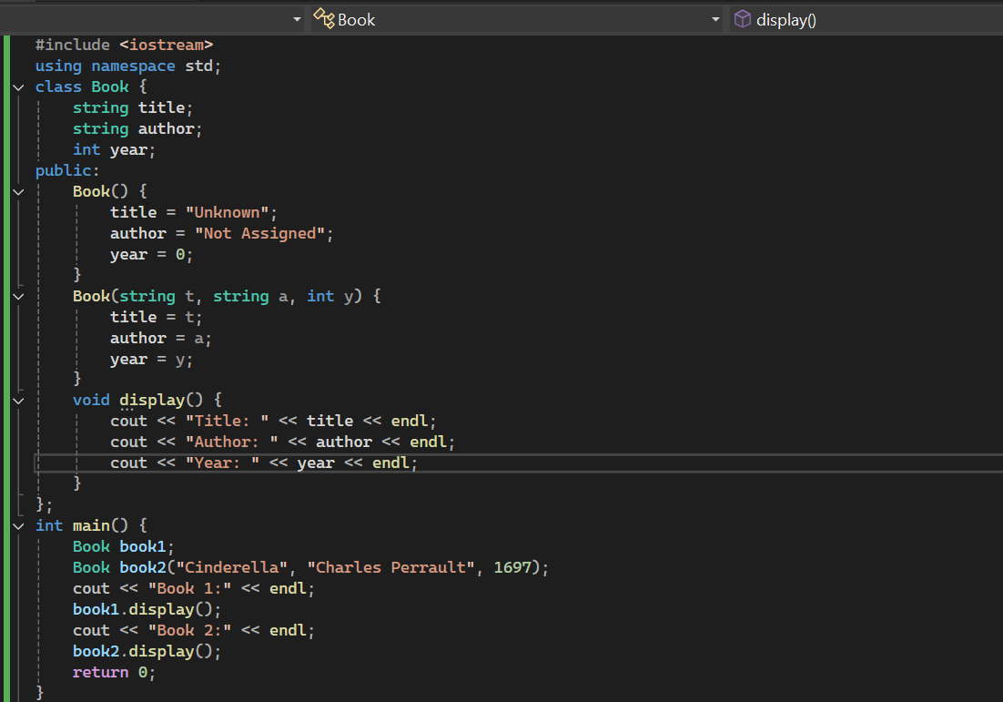

Output:
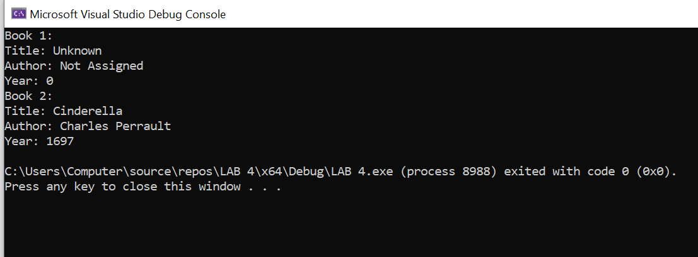

Task 2
Scenario: An Online Shopping System sometimes needs to copy details of an existing product into another object (e.g., when creating a duplicate listing).

- Create a class Product with members:
  - string name
  - double price
  - string category

Define:

- A parameterized constructor to set product details.

- A copy constructor that copies details from another object.
- A display() function.

Main:

- Create a product using the parameterized constructor.
- Create another product using the copy constructor.
- Display both and show that the copy worked.

Code:

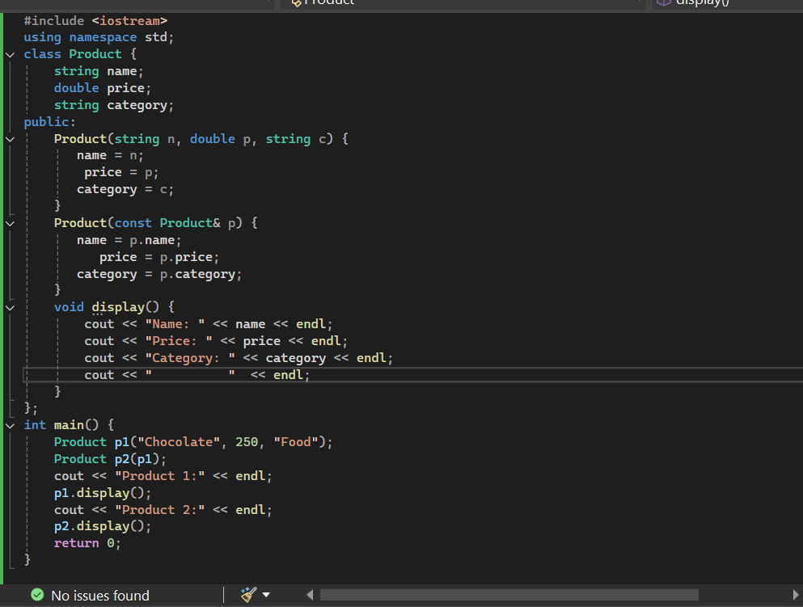

Output:

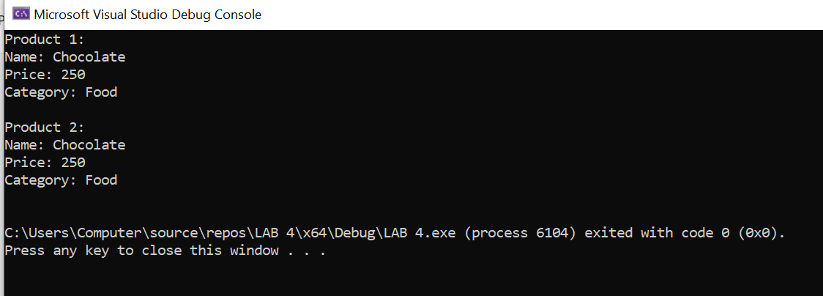

Task 3
Scenario: A Bank System automatically closes accounts when the program ends.

- Create a class BankAccount with members:
  - string accountHolder
  - double balance

Define:

- A parameterized constructor that initializes account details.
- A destructor that prints:
"Account of <accountHolder> with balance <balance> is now closed."

Main:

- Create two bank account objects.
- When the program ends, observe how destructors are called automatically.

Code:

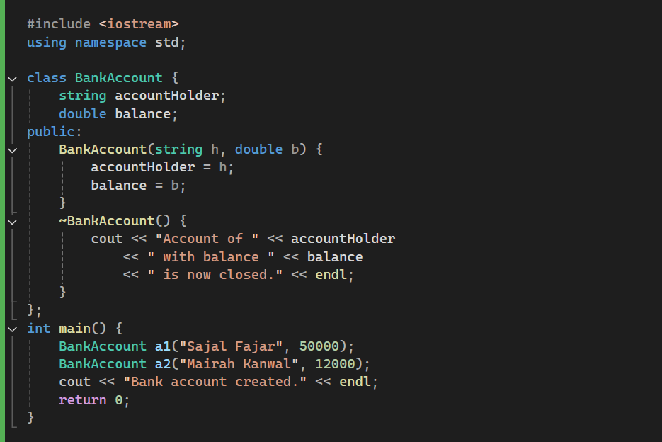

Output:

